Name: Mushtaque Ali
Caste: Khaskheli
Subject: Programming Lab
Sec: H
Task 01
INPUT
#include<iostream>
using namespace std;
int main ()
{
int num1, num2;
cout<<"Enter NO#1.\n";
cin>>num1;
cout<<"Enter NO#2.\n";
cin>>num2;

if(num1==num2)
cout<<"\n"<<num1<<" and "<<num2<<” are Equal” <<endl;
else
cout<<"\n"<<num1<<" and "<<num2<<” are not Equal” <<endl;
return 0;
}
OUTPUT
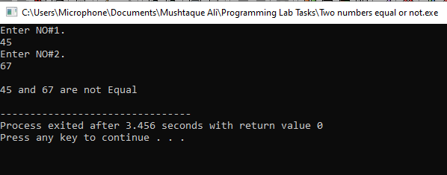
Task 02
INPUT
#include<iostream>
using namespace std;
int main()
{
int per;
cout<<"\nEnter your percentage\n";
cin>>per;

if(per>=90 && per<=100)
cout<<"\nYour Grade is A1";
else if (per>=80 && per<90)
cout<<"\nYour Grade is A";
else if (per>=70 && per<80)
cout<<"\nYour Grade is B";
else if (per>=60 && per<70)
cout<<"\nYour Grade is C";
else if (per>=0 && per<60)
cout<<"\nFail";
else
cout<<"\nInvalid Entry\n\n";
return 0;
}

OUTPUT
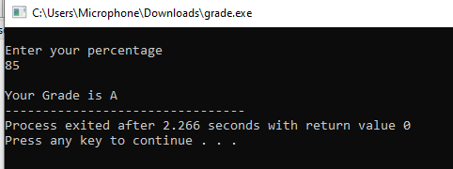

Task 03
INPUT

#include <iostream>
using namespace std;
int main()
{

int eng, ict, math, phy, prog;
float obtainm, per;

cout<<"Enter your English marks"<<endl;
cin>>eng;

cout<<"Enter your ICT marks"<<endl;
cin>>ict;

cout<<"Enter your math marks"<<endl;
cin>>math;

cout<<"Enter your physics marks"<<endl;
cin>>phy;

cout<<"Enter your programming marks"<<endl;
cin>>prog;

cout<<"\n";

obtainm=eng+ict+math+phy+prog;
cout<<"Your obtained marks are "<<obtainm<<" out of 500"<<endl;

per=obtainm/500*100;
cout<<"Your percentage is "<<per<<endl;

if(per>=90 && per<=100)
cout<<"\nYour Grade is A1";

else if (per>=80 && per<90)
cout<<"\nYour Grade is A";

else if (per>=70 && per<80)
cout<<"\nYour Grade is B";

else if (per>=60 && per<70)
cout<<"\nYour Grade is C";
else if (per>=0 && per<60)
cout<<"\nFail";
else
cout<<"\nInvalid Entry\n\n";

return 0;
}

OUTPUT
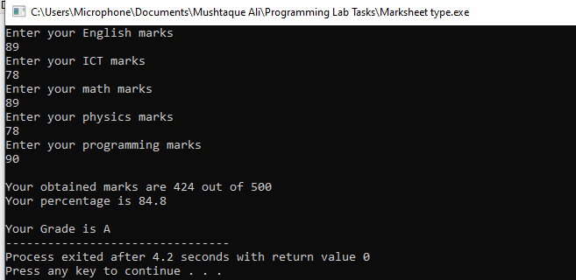

Task 04
INPUT
#include<iostream>
using namespace std;
int main ()
{
int number;
cout<<"\nEnter a number\n";
cin>>number;
if(number%2==0)
cout<<"\n"<<number<<" is even\n";
else
cout<<"\n"<<number<<" is odd\n";
return 0;
}
OUTPUT
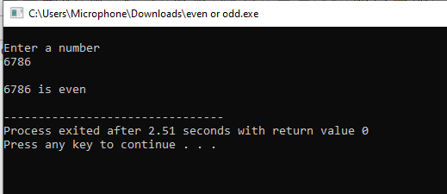

Task 05
INPUT
#include<iostream>
using namespace std;
int main()
{
int number;
cout<<"\nEnter a number\n";
cin>>number;

if(number>0)
cout<<"\n"<<number<<" is positive number\n";
else if(number<0)
cout<<"\n"<<number<<" is negative number\n";
else
cout<<"\n"<<number<<" is zero\n";
return 0;
}
OUTPUT 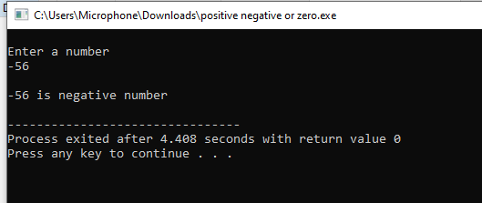
Task 06
INPUT
#include<iostream>
using namespace std;
int main()
{
int number;
cout<<"\nEnter a month number (1 to 12)\n";
cin>>number;

if(number==1)
cout<<"\nThe first month is January";
else if(number==2)
cout<<"\nThe second month is February";
else if(number==3)
cout<<"\nThe third month is March";
else if(number==4)
cout<<"\nThe fourth month is April";
else if(number==5)
cout<<"\nThe fifth month is May";
else if(number==6)
cout<<"\nThe sixth month is June";
else if(number==7)
cout<<"\nThe seventh month is July";
else if(number==8)
cout<<"\nThe eighth month is August";
else if(number==9)
cout<<"\nThe ninth month is September";
else if(number==10)
cout<<"\nThe tenth month is October";
else if(number==11)
cout<<"\nThe Eleventh month is November";
else if(number==12)
cout<<"\nThe twelfth month is December";
else
cout<<"Invalid input";

return 0;
}
OUTPUT
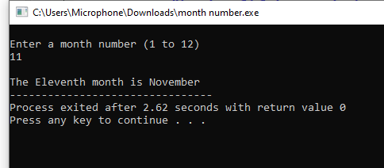

Task 07
INPUT
#include<iostream>
using namespace std;
int main()
{
int num1, num2;
cout<<"Enter NO#1.\n";
cin>>num1;
cout<<"Enter NO#2.\n";
cin>>num2;

if(num1>num2)
cout<<"\n"<<num1<<" is greater than "<<num2<<endl;
else if(num1<num2)
cout<<"\n"<<num1<<" is less than "<<num2<<endl;
else
cout<<"\nBoth numbers are equal\n";
return 0;
}

OUTPUT
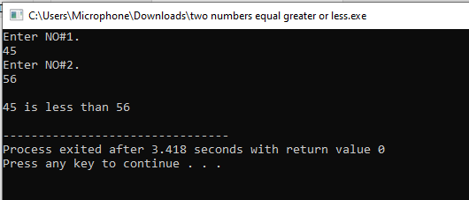

Task 08
INPUT
#include<iostream>
using namespace std;
int main ()
{
int num1, num2, num3;
cout<<"Enter a number\n";
cin>>num1;
cout<<"Enter another number\n";
cin>>num2;
cout<<"Enter third number\n";
cin>>num3;

if(num1>num2 && num1>num3)
cout<<"\n"<<num1<<" is the largest\n\n";
else if(num2>num1 && num2>num3)
cout<<"\n"<<num2<<" is the largest\n\n";
else if(num3>num2 && num3>num1)
cout<<"\n"<<num3<<" is the largest\n\n";
else if (num1==num2 && num1>num3)
cout<<"\n"<<num1<<" is the largest\n\n";
else if (num1==num3 && num1>num2)
cout<<"\n"<<num1<<" is the largest\n\n";
else if (num2==num3 && num2>num1)
cout<<"\n"<<num2<<" is the largest\n\n";
else if (num1==num2 && num2==num3)
cout<<"\nAll numbers are equal\n\n";
else
cout<<"\nInvalid Entry\n\n";

return 0;
}

OUTPUT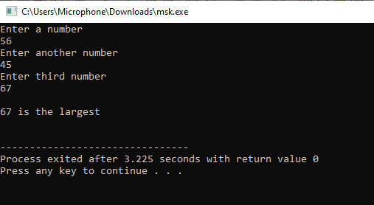

Task 09
INPUT
#include<iostream>
using namespace std;
int main()
{
float num1, num2;
char oper;
cout<<"Enter a number\n";
cin>>num1;
cout<<"Enter operator (+ , - , * , /)\n";
cin>>oper;
cout<<"Enter another number\n";
cin>>num2;

if(oper=='+')
cout<<"\nThe sum is "<<num1+num2<<"\n\n";
else if(oper=='-')
cout<<"\nThe subtraction is "<<num1-num2<<"\n\n";
else if(oper=='*')
cout<<"\nThe product is "<<num1*num2<<"\n\n";
else if(oper=='/')
cout<<"\nThe division is "<<num1/num2<<"\n\n";
else
cout<<"Invalid Entry";

return 0;
}

OUTPUT
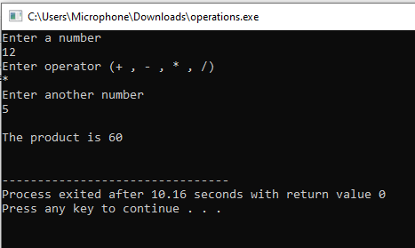

Task 10
INPUT
#include<iostream>
using namespace std;
int main ()
{
int id, unit, bill;
string name;
cout<<"\nEnter your name: ";
getline(cin, name);
cout<<"\nEnter your ID number: ";
cin>>id;
cout<<"\nEnter unit consumed: ";
cin>>unit;

if(unit>=0 && unit<200)
{
bill=unit*5;
cout<<"\nYour electricity bill will be "<<bill<<endl;
}
else if (unit>=200 &&unit<400)
{
bill=199*5 + (unit-199)*10;
cout<<"\nYour electricity bill will be "<<bill<<endl;
}
else if (unit>=400 &&unit<500)
{
bill=199*5 +199*10 + (unit-199-199)*15;
cout<<"\nYour electricity bill will be "<<bill<<endl;
}
else if (unit>=600)
{
bill=199*5 +199*10+199*15 + (unit-199-199-199)*20;
cout<<"\nYour electricity bill will be "<<bill<<endl;
}
else
cout<<"Error occurred\n";
return 0;
}

OUTPUT
